 | School of Electrical and Information Engineering  University of the Witwatersrand, Johannesburg  ELEN4002/4012: Project Specification Outline | To be completed by supervisor  Assessment:  ☐ Deficient ☐ Acceptable  ☐ Good ☐ Excellent

Project Title: | Image compression based on non-parametric sampling in noisy environments

Group Number: | 19G01 | Supervisor Name: | Prof. Fambirai Takawira
Student Name A: | Kishan Narotam | Student Name B: | Nitesh Nana
Student Number A: | 717 931 | Student number B: | 720 064

Ethics: ☐ Request for waiver (does not involve human participants or sensitive data)
_________________ ☐ Copy of ethics application attached (Non-medical) – School Committee
Supervisor Signature ☐ Copy of ethics application attached (Medical) – University Committee

Project Outline: (give a brief outline such that ethics reviewers understand what will be done, 100 words maximum)
A variety of images will be transmitted via a channel and received after being processed in noisy environments, with the ultimate goal of image compression. The proposed method includes creating holes within the image and transmitted through the channel. The image is received at the receiver and processed in order to fill the holes exploiting the structure of the original image.

Project Specification:
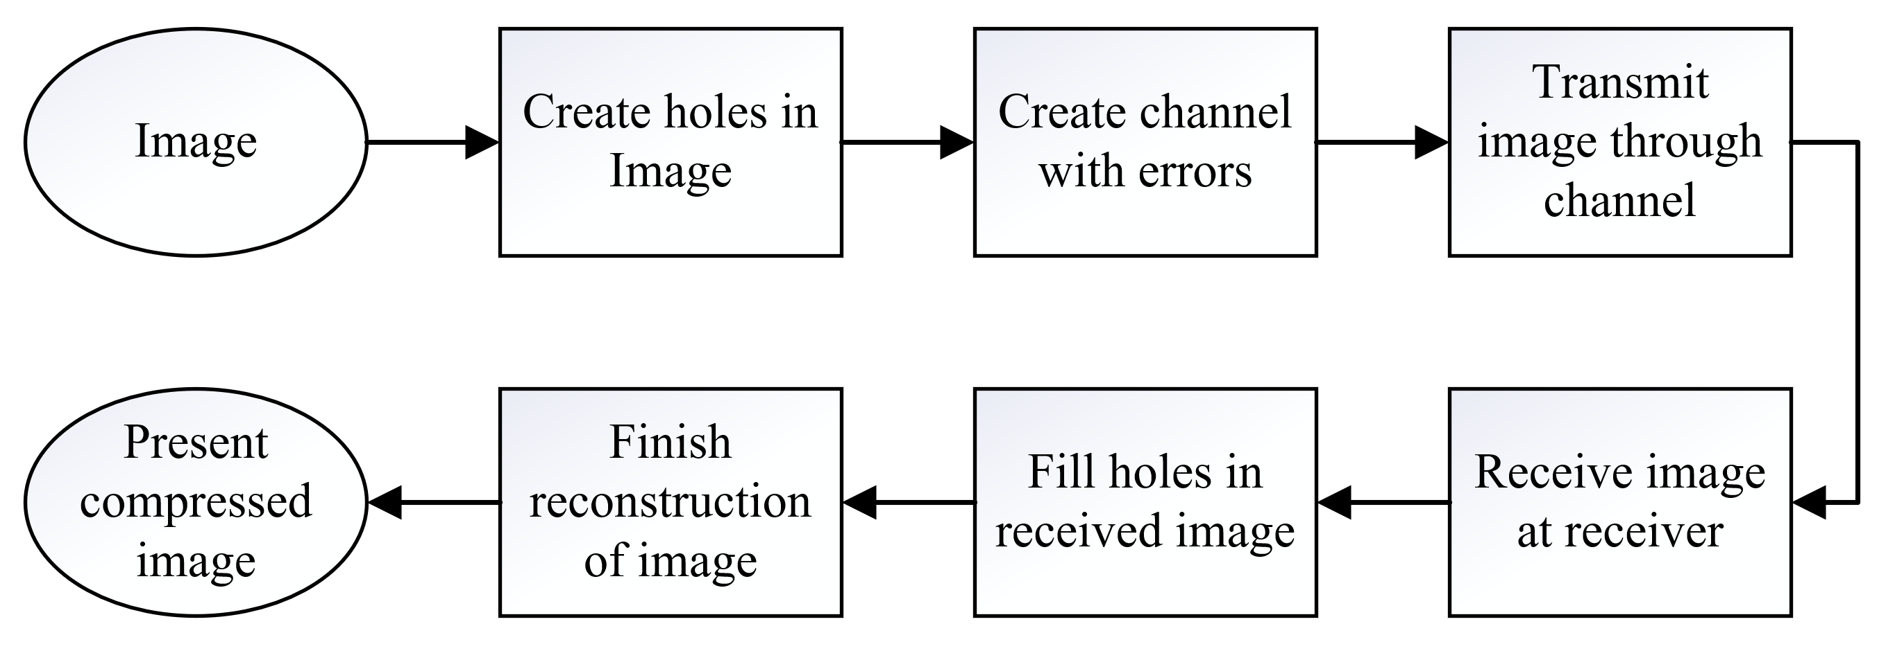

An image will be chosen for compression utilizing the compression technique of creating holes in the images and after transmitting, filling those holes resulting in a compressed image.
The holes will be created manually using current compression algorithms (fractal compression). Once the holes are created, the image will be transmitted via a simple channel that will introduce errors randomly.
The image will be received at the receiver, and knowing where the holes are present, will fill them accordingly. The received image with the filled holes will be reconstructed and presented as the final compressed image.

Should time be permitting, DCT compression will be utilized on the same image and used a way of comparing the created holes compression technique with a common practice of image compression for JPEGs.

Milestones: |  | Preliminary Budget & Resources:
Budget:
No budget is required and personal
laptops/computers will be utilized.

Resources:
Since this project requires no physical
hardware building, only computers will be
utilized in implementing the algorithms and
processing the images.

The various programs used to implement the
algorithms will require the relevant software
licenses (most probable is MATLAB).
Student licenses provided by the university.

Processing the images, will require the actual
images (image data), these could range from
textured images to some more complex.

Risks / Mitigation:
- University protest action may cause unforeseen interruptions
- Eskom’s current power crisis may result in data corruption as everything will be done on computers. However, since laptops will be utilized, this may be prevented, but laptops have a limited battery life and so work must be saved throughout the process of image compression.

